Flow chart:
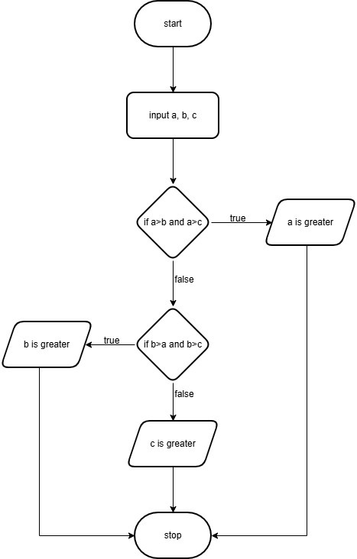
Algorithm:
- Start
- Input three numbers a, b, and c
- If a > b and a > c, then
- Print “a is greater”
- Else if b > a and b > c, then
- Print “b is greater”
- Else
- Print “c is greater”
- Stop

Code Tantra: 